**What is Web 3.0 and Why the Tech is Disruptive**

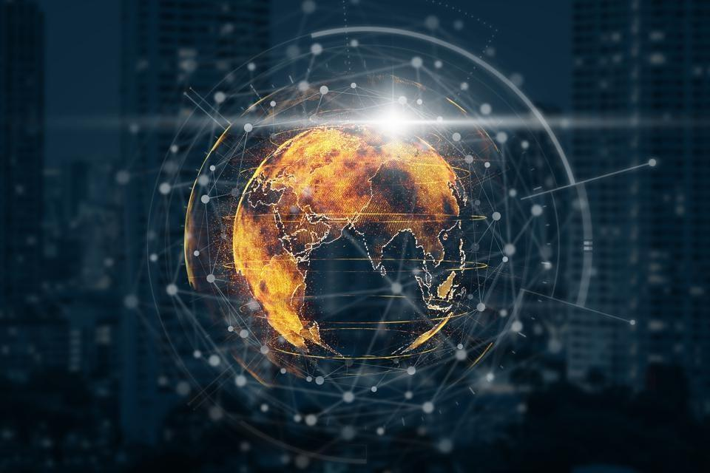

Web 3.0 holds the potential of transforming the internet industry forever. Through different capabilities, web 3.0 is disrupting the internet industry, and poses a threat to the currently existing business models that have been built on web 2.0.

As an illustration, the conventional web 2.0 currently being used today brought a lot of benefits. However, it was accompanied by consumer privacy concerns with people's accounts and information being hacked as well as personal information being used to target people with exploitative advertising. Web 3.0 has the potential of addressing these consumer privacy issues and bringing a fairer internet whereby individuals are sovereign.

Instead of accessing the internet via services worked out by companies such as Apple, Google, or Facebook, individuals will own and control sections of the internet, and users will get to own and control who can profit from their time and information with web 3.0, unlike in web 2.0.

Instead of worrying about internet companies invading your privacy, misusing your data, and the government spying on you, with web 3.0, you will manage to log in securely over the internet without being tracked through internet identity.

Web 3.0 technology has existed for a while; however, just like its vital component, blockchain, it has left many racking their brains on what it entails. This article explains how Web 3.0 works and how the technology is disruptive.

**The Road to Web 3.0**

As its name suggests, two internet versions have preceded web 3.0; web 2.0 and web 1.0. They have gradually added more online services and unlocked new capabilities.

The initial version of web technology was web 1.0. Primarily depending on HTML, HTTP, and URL technologies, its primary purpose was to enable users to locate information through text, pictures, and an excellent design, maybe a hit counter displayed on its platforms. The critical problem with this web technology was; users were unable primarily to interact freely since it was 'read-only .' Discussions were conducted offline. It was concerned with viewing and creating content.

Web 2.0, on the other hand, transcended Web 1.0 by grouping information on websites, enabling the free flow of data from site owners to users and giving users tools for creating content. Some of the things it came with was a sophisticated design, web applications where users could sign up with a user name, as well as the capability to access the internet with a mobile phone. This web version is what is predominantly being used today. In fact, companies such as Facebook, Uber, and Airbnb, among other eCommerce websites emerged during the reign of web 2.0. Nonetheless, many people are seeking a new web generation to deal with the existing web generation's paradoxes.

**What is Web 3.0?**

The term web 3.0 was coined in 2006 by John Markoff, a New York Times reporter who described it as a third generation of the internet. Other experts put forward that web 3.0 is a return to the original internet idea of semantic Web conceptualized by Tim Bernes-Lee in 1999.

The semantic web, as conceptualized by Tim Bernes-Lee, is an advanced version of the current internet which would be predominantly run by intelligent agents or machines capable of processing content in much the same way as humans.

In his article, John Markoff describes the projects directed at developing Web 3.0 as all exploiting progressively more powerful computers capable of rapidly and thoroughly combing through the Web. As an illustration, web 2.0 is capable of connecting a rental housing Website using Google Maps to render a useful and better service that would indicate the location of each rental listing.

On the other hand, semantic web developers are capable of creating a system that can give a reasonable and thorough response to a question such as: "I'm searching for a warm-weather location for vacation, and I have a budget of $4, 000… And oh, I have a ten-year-old child”. Such a query can consume hours of sifting through lists of hotels, flights, and car rentals under the current system of web 2.0. However, the same search under web 3.0 would ideally retrieve a complete vacation package that seemed as though it had been put up together by a human travel agent.

Thus far, the fundamental principle behind Web 3.0 is defining structured data and linking it for more capable exploration, automation, integration, and reuse across different applications. Also, the technology marks a transition from a web of connected documents to a web of connected data.

Turning now to decentralization. Decentralization will be possible with web 3.0 through a distributed ledger technology-block chain. Blockchain differs from the centralized databases used in web 2.0. It gives users full control of information and transactions while rendering a tamper-proof log of sensitive activity.

The critical working of blockchain technology is through gathering information together in groups known as blocks that hold sets of information. These blocks have particular storage capacities, and when full, they are closed and are aligned to the previously filled block, creating a chain of data referred to as the blockchain. In the case that a transaction within a specific block is changed, deleted, or added, the particular block is rejected by the rest of the network, which makes the system very secure and reliable.

Bearing this in mind, blockchain technology holds the possibility of giving web 3.0 high transparency and security levels. Besides, decentralized networks have no single point of failure, which means that the network cannot be brought down through a node or server attack. Currently, blockchain is used in cryptocurrency rendering access to numerous decentralized applications and enabling users to create [smart contracts](https://www.ibm.com/sa-en/topics/smart-contracts) -auto-executing programmed agreements documented in the blockchain operating on an *if, then*logic.

Web 3.0 will also be facilitated by a sophisticated artificial intelligence software capable of decrypting natural language and understanding user intention. Consequently, it is anticipated to render more intuitive user-centric interactions in comparison to the current internet framework which to a large extent depends on the direct user inputs.

**Why the Tech is Disruptive**

* **Decentralization**

The Web initially set out as a decentralized system founded on DNS, allowing anyone to purchase, own, and manage their domain name and move it across different hosts that suited them and with full ownership and control over all the original data. However, as the Web developed, the online presence grew more centralized on corporate platforms. For instance, an individual who registers a Facebook account cannot just move that account with all its content and followers somewhere else because they are tied to that network.

On the other hand, web 3.0 being decentralized, depends on a peer-to-peer network centered on a community. Instead of a group of high-powered servers, the community's internet-connected devices host websites or applications. Each website or application is distributed across different nodes based around different devices. This process takes control from centralized social networks and authorities and gives that control to everyone, enhancing equality. It also minimizes the possibility of a server crash, hackers crashing a website or an authoritarian government manipulating or censoring people's opinions over the internet.

* **Greater information availability and connectivity**

Social networks are unwilling to exchange data; however, decentralized data networks on web 3.0 will carry along the all-inclusive tail of data generators into the rising data economy. The ultimate outcome of this is the availability of large data sets and the ability to harmonize and promote the long tail of data, service, work, and content providers that are the voiceless actors to many of the acute global problems in areas such as food, health, finance, and sustainability.

The more information linked to the internet, the more data sets available for algorithms to analyze and filter. Consequently, implementation of the web technology will render accurate information capable of accommodating the user's specified needs.

* **Increasing Browsing efficiency**

Being a social web, web 2.0 enables users to generate and distribute content and also inspires them to render data and metadata in simple ways such as tagging, comments, ratings, and blogging. Consequently, web 2.0 applications are gathering massive data amounts; however, the data is poorly organized, highly subjective, and usually submerged in a low-quality content silo. To make matters worse, social web applications have not dealt with this issue, merely presenting content to their users in a sort of unclear aggregations.

Artificial intelligence in web 3.0 will sieve and weed out valuable information from a massive chunk of data and render the data it thinks is appropriate for a specific user, which means users will experience more efficient browsing.

AI will also distinguish between legitimate and falsified data on the internet. As an illustration, Google's AI system recently removed nearly 100,000 negative ratings on the Robinhood app from the Play store after identifying attempts of manipulating ratings with the intention of purposedly downvoting the app.

* **Personalized internet experiences**

Internet users are annoyed with being barraged with web advertisements. However, advertisements can be beneficial when they are pertinent to an individual's interests and needs.

By using sharper AI algorithms and targeting precise audiences in accordance with consumer data, web 3.0 will improve advertising. Also, users will have an enhanced experience with support personnel through web 3.0 intelligent chatbots.

* **Users control over who profits from their time and information**

Lastly, decentralized data networks will enable data generators to exchange their data without losing control of ownership or relinquishing privacy or dependence on third-party middlemen. This will allow people to own their data and be compensated for it and their time. For that reason, competition among internet firms will largely increase, and dominance by large corporations will be reduced.

Web 3.0 also carries several risks. Some of them preexisting web risks, hyper-targeted spam, unauthorized access to sensitive information, social phishing, and identity theft. Effective solutions should be developed to address these risks.

To sum it up, the internet ecosystem is dynamically evolving to fulfill society's rising expectations. Consumers should be cognizant of and educated on the future of the internet to avoid digital whiplash in the future in case technologies like web 3.0 grow large.